Merge sort optimal solution

Tree binary - parent shortest path

Matrices round spiral sysout

**Merge sort**

In the Defined array

Divide the array from the middle

And sort the two sub arrays

**Insertion**

Pick first 2 elements, find the smaller one

Store the smaller element in a variable

Place the smaller one in first location.

Do the comparison for the whole array/list two elements at one time

And do the same for the new sublist formed such that left side of the array should be sorted at the end.

**Selection**

Pick middle element of the array, compare it with the first element in the list and place the smaller one at the first place.

Store the smaller element in a variable

Do the same comaprison with the whole array such that the middle element is placed at the correct position

And all element before the middle element is sorted.

Now from the right side list

Find the middle number/element

Do the same above steps.

**Quick**

**Step 1** − Choose the highest index value has pivot  
**Step 2** − Take two variables to point left and right of the list excluding pivot  
**Step 3** − left points to the low index  
**Step 4** − right points to the high  
**Step 5** − while value at left is less than pivot move right  
**Step 6** − while value at right is greater than pivot move left  
**Step 7** − if both step 5 and step 6 does not match swap left and right  
**Step 8** − if left ≥ right, the point where they met is new pivot

**Bubble**

Pick first 2 elements, find the smaller one

Store the smaller element in a variable

Place the smaller one in first location.

Do the comparision for the whole array/list two elements at one time

Now when one traverse is done, then start the comparision from the end of the list.

Traverse the whole array such that find the smallest number in the array

Now place the smallest num at first position

Now do the same for the whole array

# **Reverse words in a given string**

Example: Let the input string be “i like this program very much”. The function should change the string to “much very program this like i”

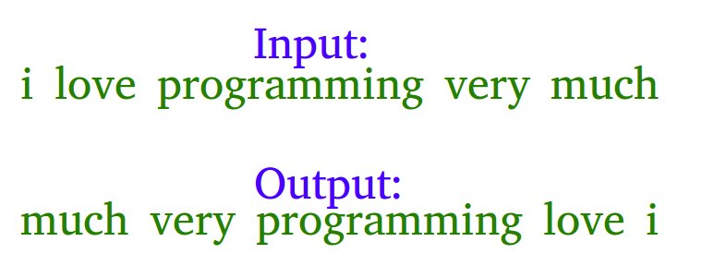

Examples :

Input : s = "geeks quiz practice code"  
Output : s = "code practice quiz geeks"  
  
Input : s = "getting good at coding needs a lot of practice"  
Output : s = "practice of lot a needs coding at good getting"

## [We strongly recommend that you click here and practice it, before moving on to the solution.](http://www.practice.geeksforgeeks.org/problem-page.php?pid=282)

Algorithm:

1) Reverse the individual words, we get the below string.  
 "i ekil siht margorp yrev hcum"  
2) Reverse the whole string from start to end and you get the desired output.  
 "much very program this like i"